The Nano Frontier: Where Science Meets the Impossible

探索奈米的邊界:科學邂逅不可能

Kai-Lin Yang(楊凱琳) 2025/05/06

Micro/Nano-Systems

Micro/Nano: basic unit of measure is the micrometer (${10}^{-6}$ m) or nanometer ( ${10}^{-9}$ m)

Electro: MEMS have electrical components

Mechanical: MEMS have mechanical parts

System: Refers to integration of components

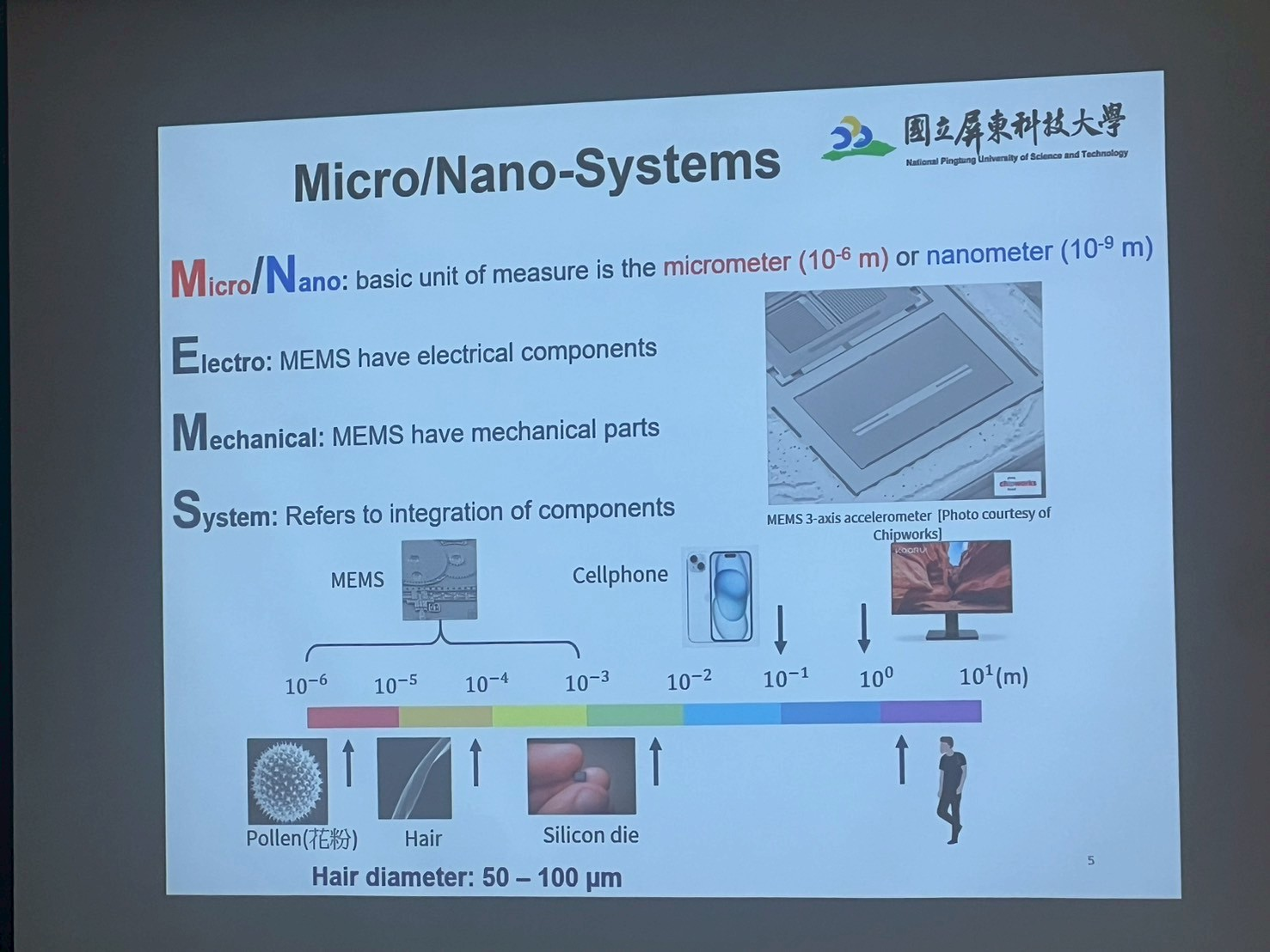

生活應用：iPhone 16 Pro

iPhone 16 Pro 採用 5級鈦金屬設計,經微噴砂處理的全新質感,精緻又細膩。鈦金屬

的強度重量比在眾金屬中名列前茅,因此打造出極為堅固又無比輕盈的機型。

5級鈦:Ti-6Al-4V。

耐腐蝕性、高強度和耐高溫能力，成為應用最廣泛的鈦合金之一

Titanium(鈦) Advantages

* Resistance to corrosion
* High Strength
* High melting point
* Non-toxic
* Low thermal expansion
* Excellent fabrication possibilities
* Light in weight

Nano-Crystalline Superplasticity(超塑性)

* Fine grain superplasticity

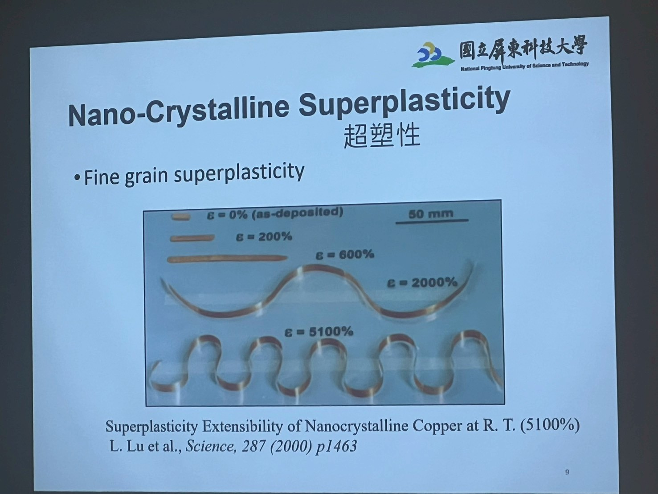

Superplasticity Extensibility of Nanocrystalline Copper at R. T. (5100%)

L. Lu et al., Science, 287 (2000) p1463

Deformation of microcrystalline grains

* GBS (Grain boundary sliding 晶界滑移)with accommodation processes
  + rain boundary migration
  + Recrystallization
  + Diffusion flow
  + Dislocation climb or glide Superplasticity
  + Grain rotation

Low Temperature or High Strain Rate Superplasticity (LTSP or HSRSP)

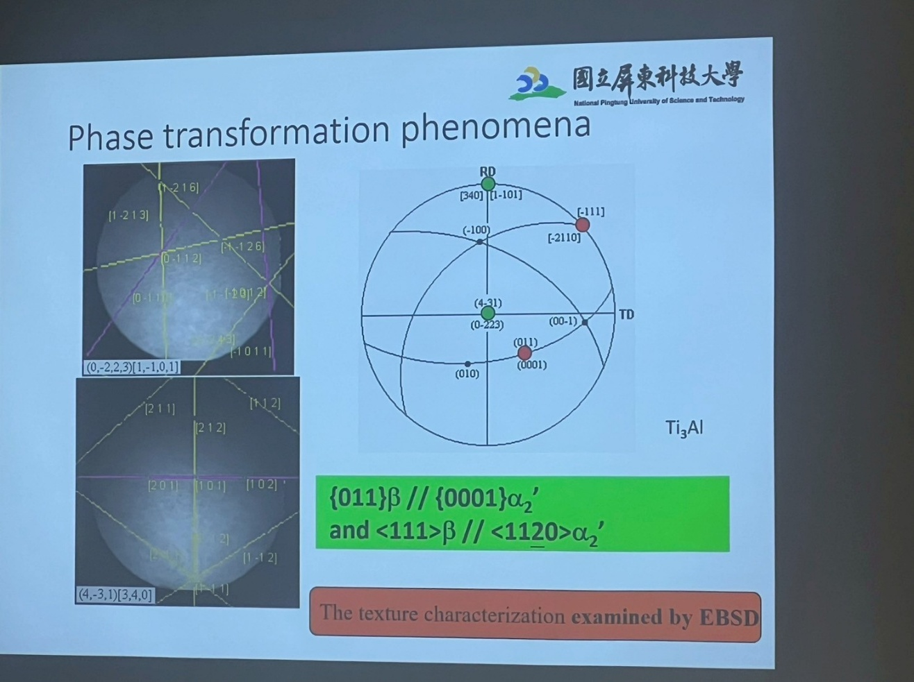Phase transformation phenomena

LTSP+DB(Diffudion Bonding)~UAV

* In our extruded (ER=90:1)

AZ31 Magnesium Alloy

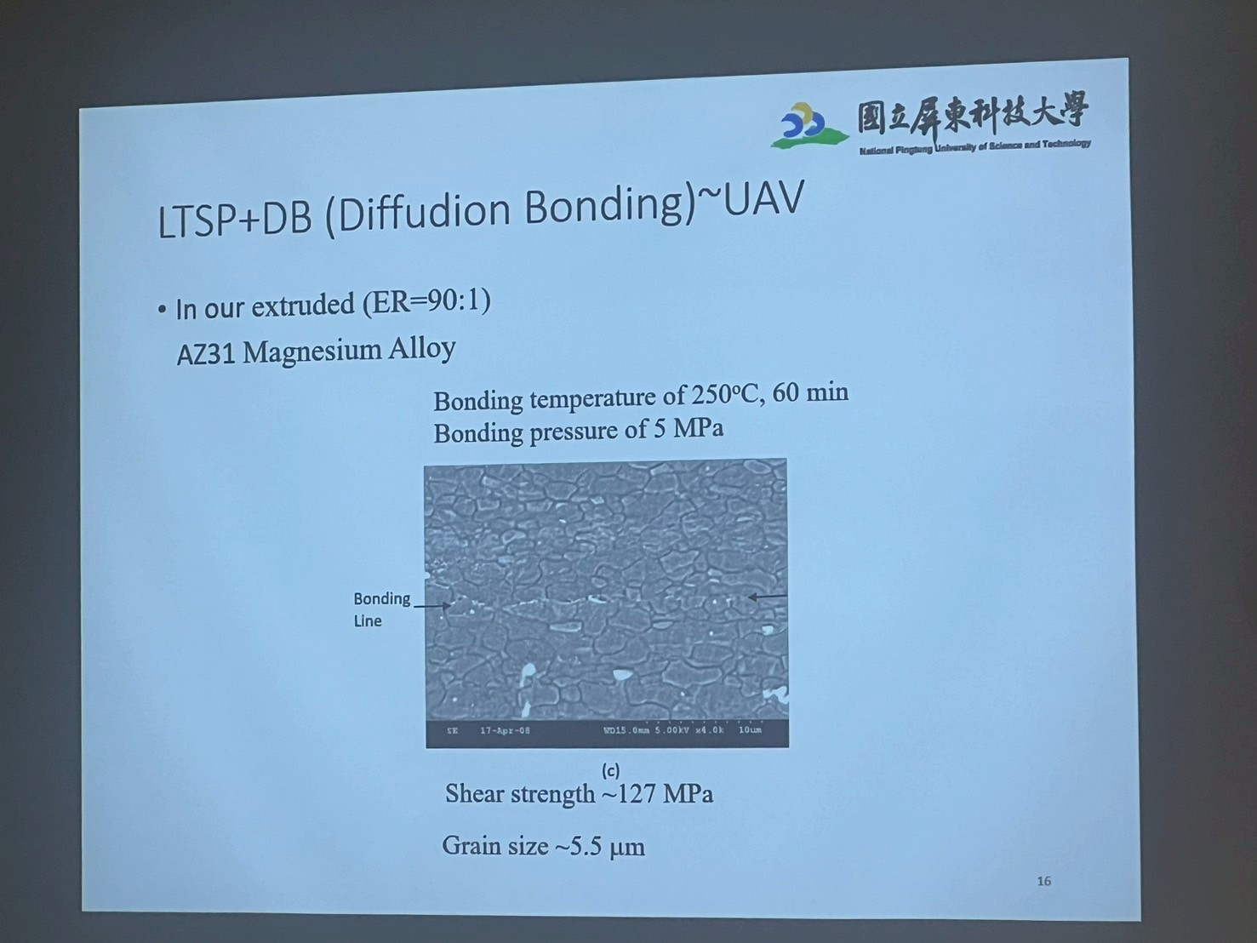

超塑性成型(Superplastic Forming,SPF)

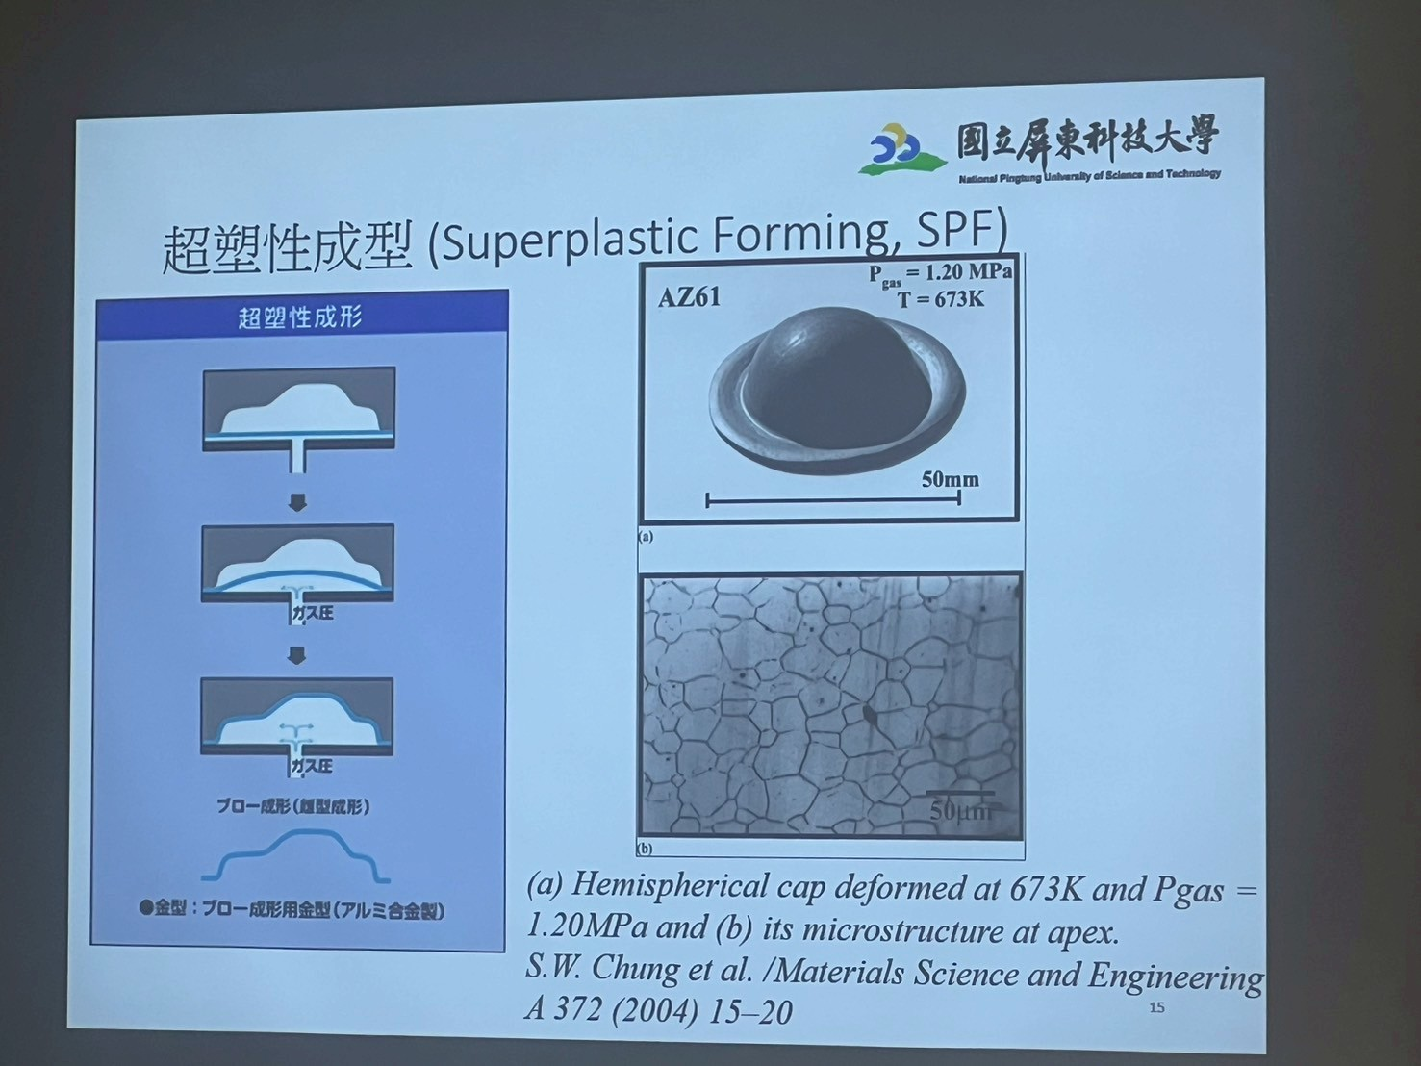



From Fine grained Metal into

Amorphous Metallic Glasses(非晶質金屬玻璃)

* Metallic Glasses : also known as metallic glass or glassy metal
* 如鋼鐵般堅硬，如塑膠般多變。
* High strength.
* High hardness.
* High tensile elongation.
* Absence of grain boundary (晶界) and segregation(偏析).

高熵合金(High-entropy alloys)

Crystalline structure and amorphous structure

* Crystalline solids contain defects (missing atoms) or dislocations.
* Amorphous metal, similar to glass, have a tightly- packed, yet random arrangement.

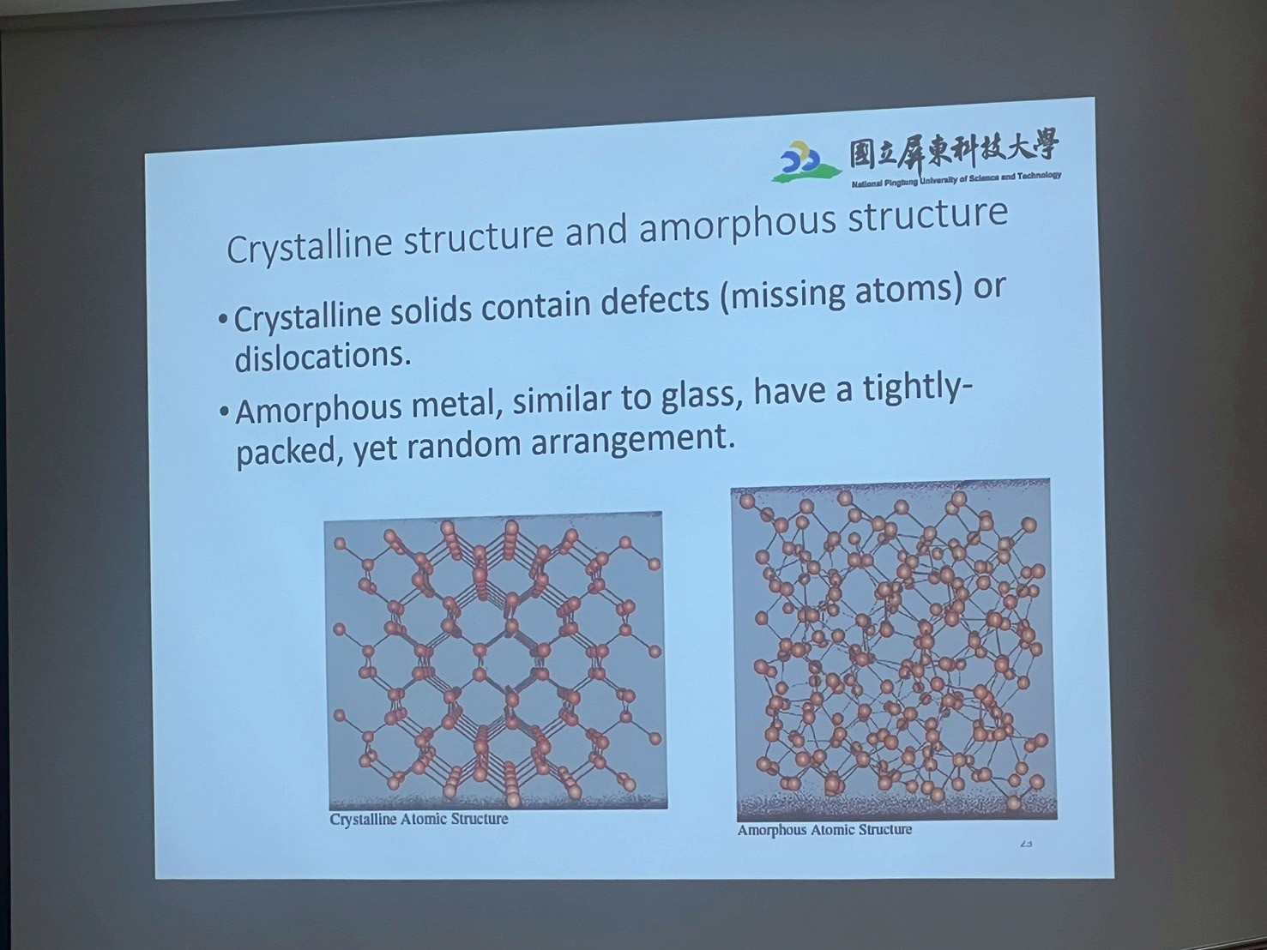

Characteristics of BMG (Bulk amorphous metallic glass,BMG)塊材非晶質金屬玻璃

* 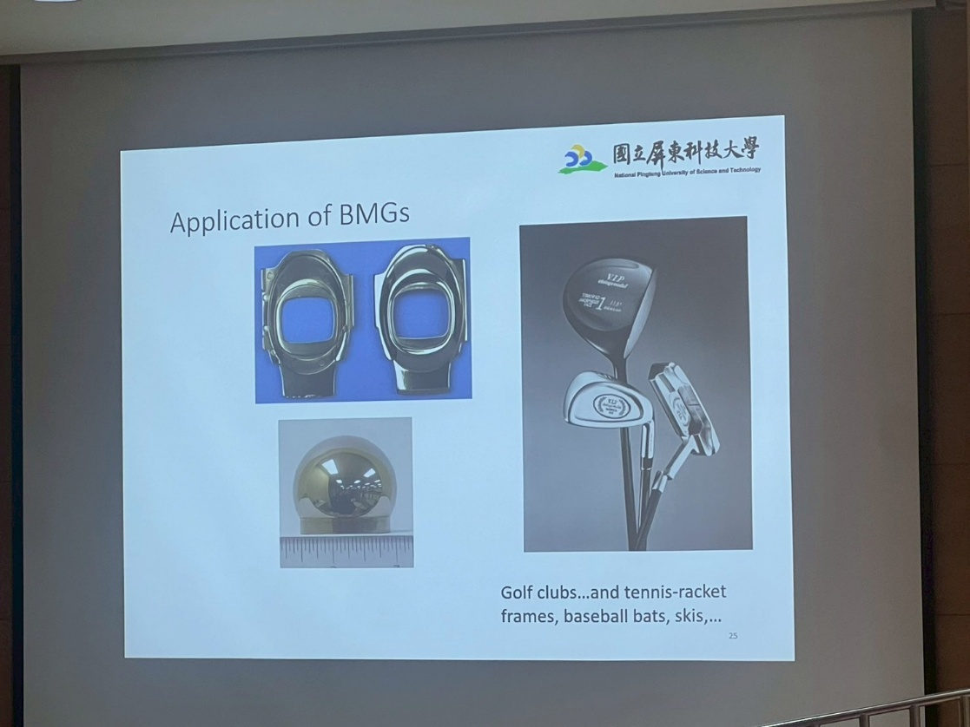High strength:>2000 Mpa
* High hardness:>500 Hv
* High fracture toughness:>70 ${Mpa.m}^{1/2}$
* High elastic strain: ~2 % at RT
* Good castability and formability:>1000 % elongation
* Superior corrosion resistance
* Good wear resistance
* Good soft magnetic properties: Fe-base BMGs
* Other interesting optical and physical proper

Microelectronics About "Scaling"

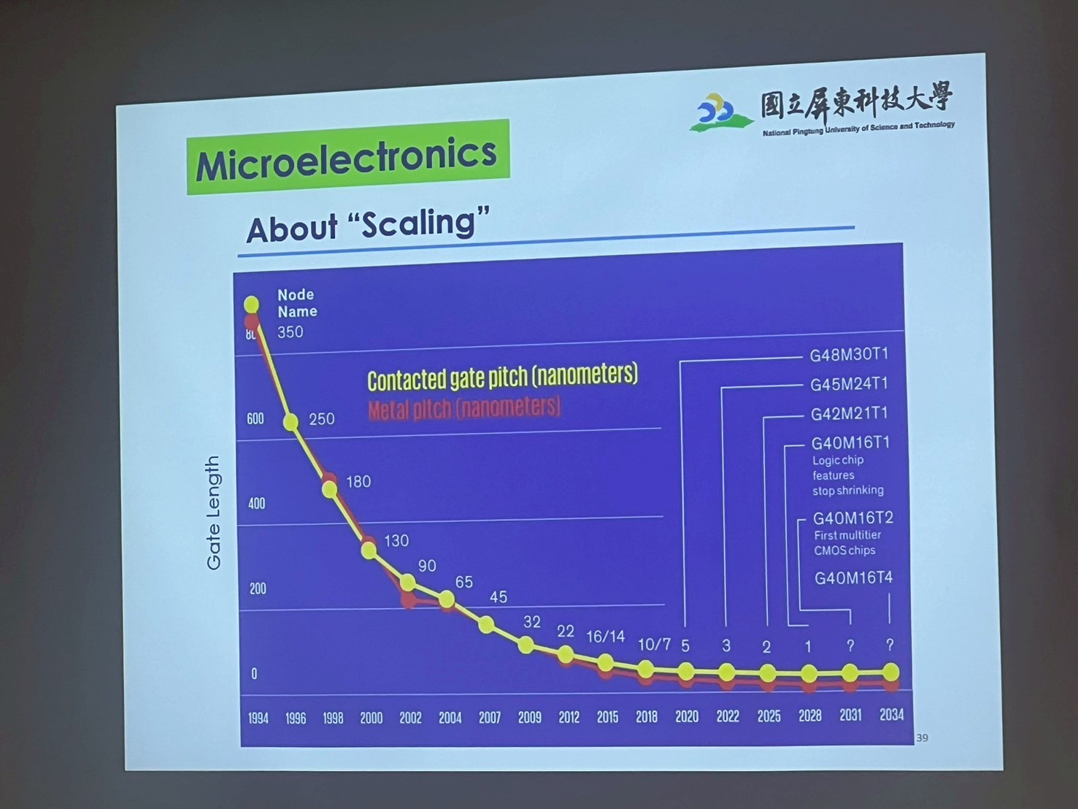

Technology node

* Historically, the process node name referred to a number of different features of a transistor including the gate length.
* Technology node is the width of line that can be processed with a minimum width. No longer length of transistor is critical at 22nm, 14nm, 10nm and 7 nm.
* In general, smaller node = smaller transistors.

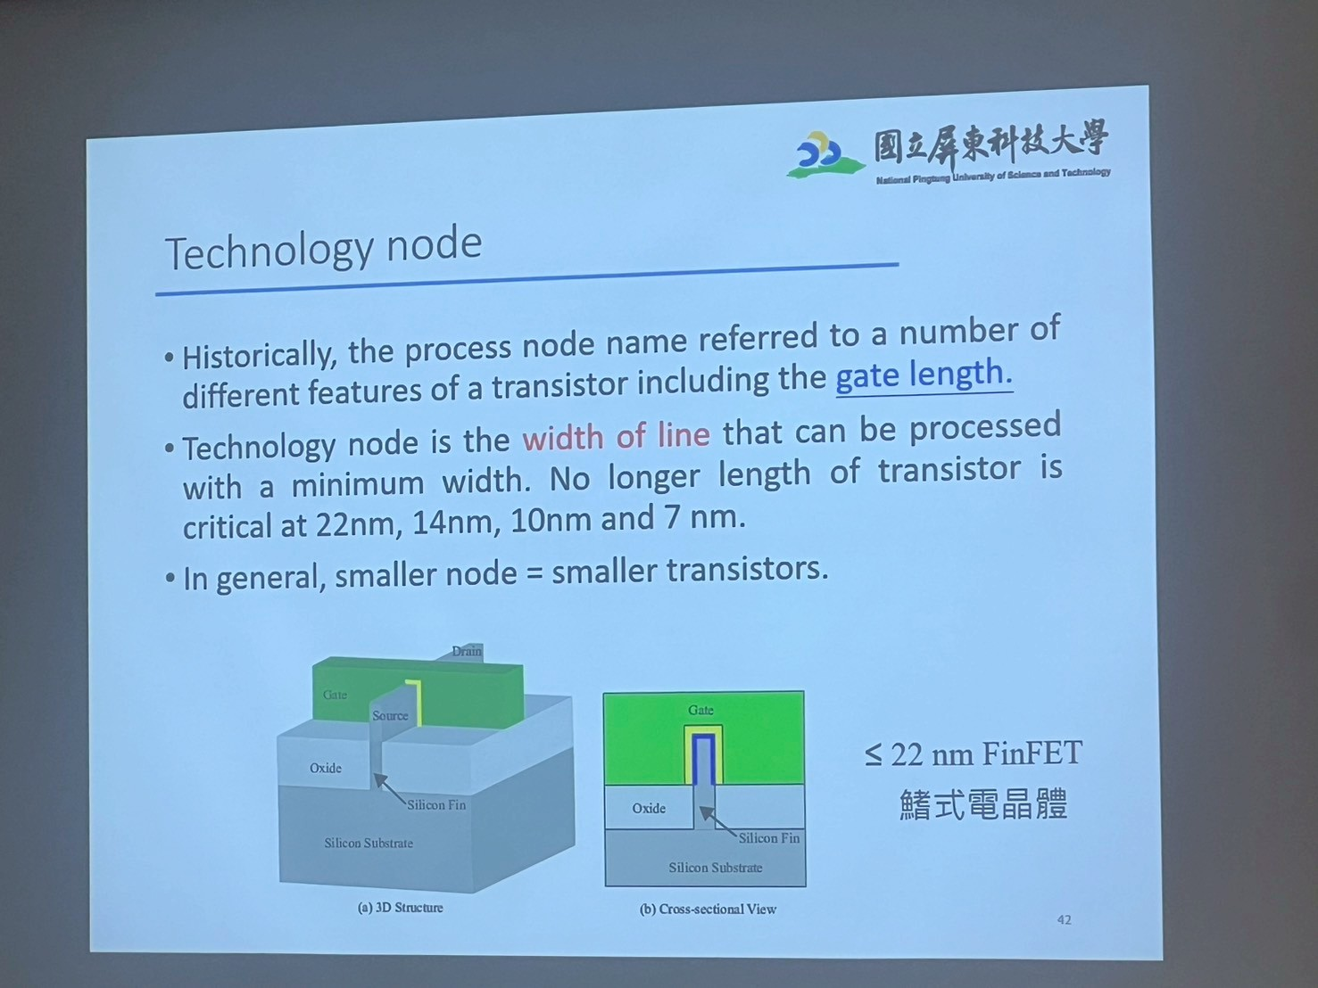

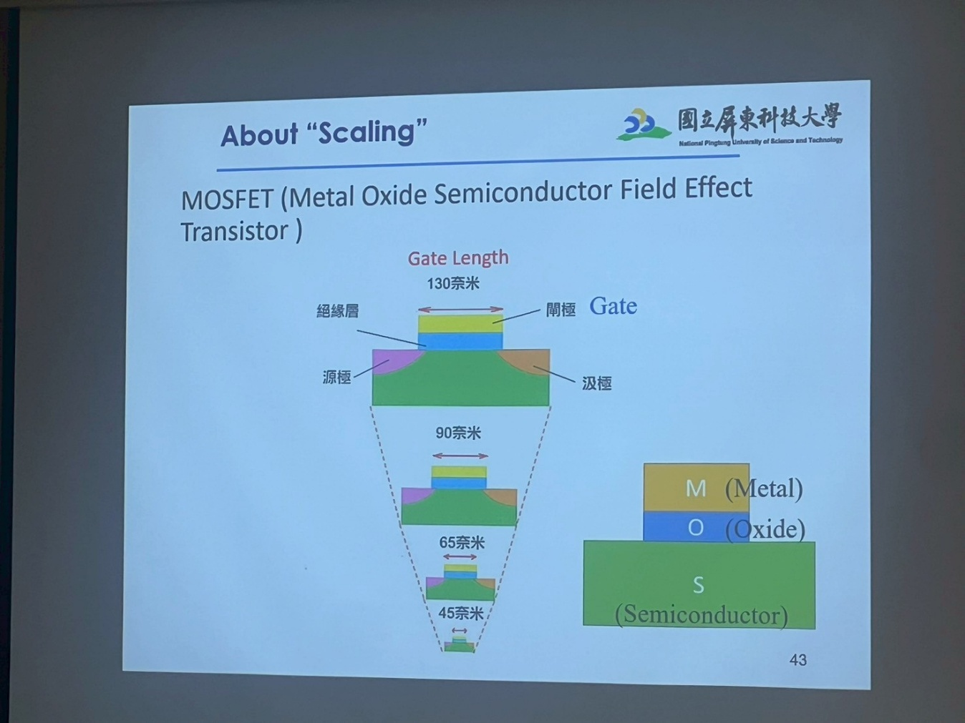About "Scaling" MOSFET (Metal Oxide Semiconductor Field Effect Transistor )

Intel Evolution of Transistor Innovation

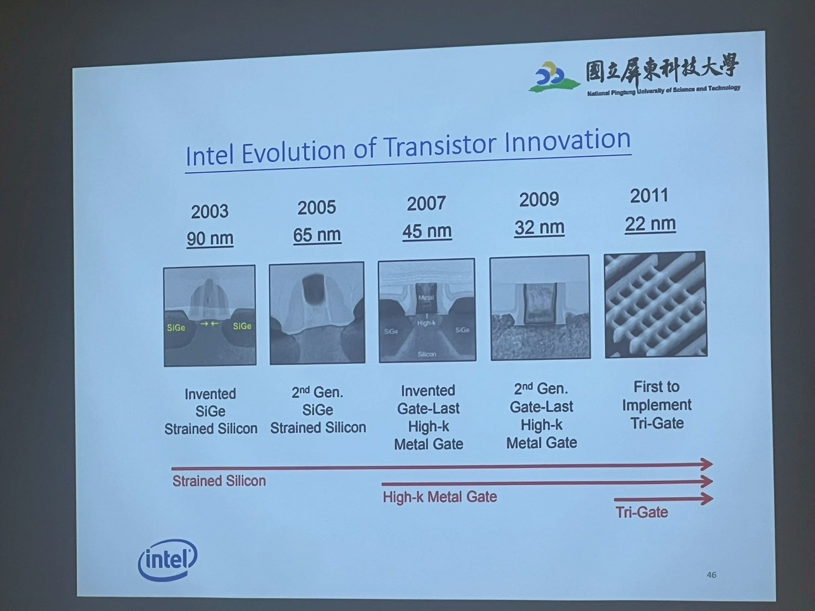

Gate-all-around FET (GAA FET)

* GAA transistors using horizontally stacked nanosheets start with alternating layers of silicon and silicon germanium (SiGe), patterned into pillars.

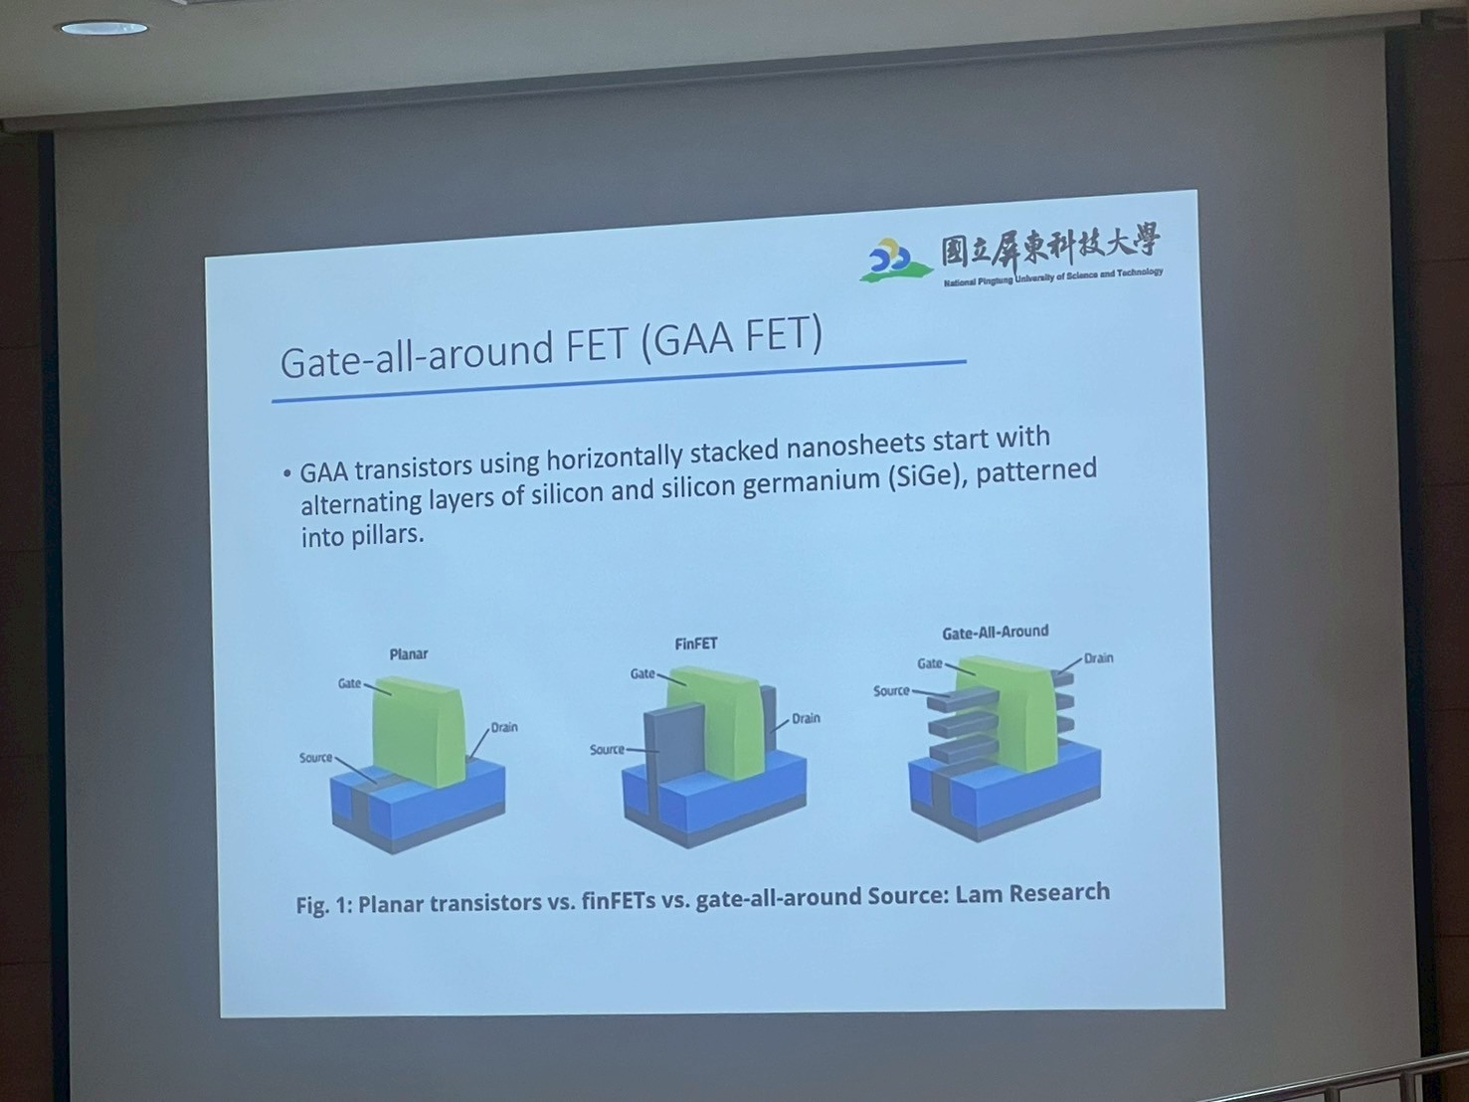

Fig 1: Planar transistors vs. finFETs vs. gate-all-around Source: Lam Research

Physical limit

New materials : MoS2、WS2、MoSe2、WSe2、Graphene?

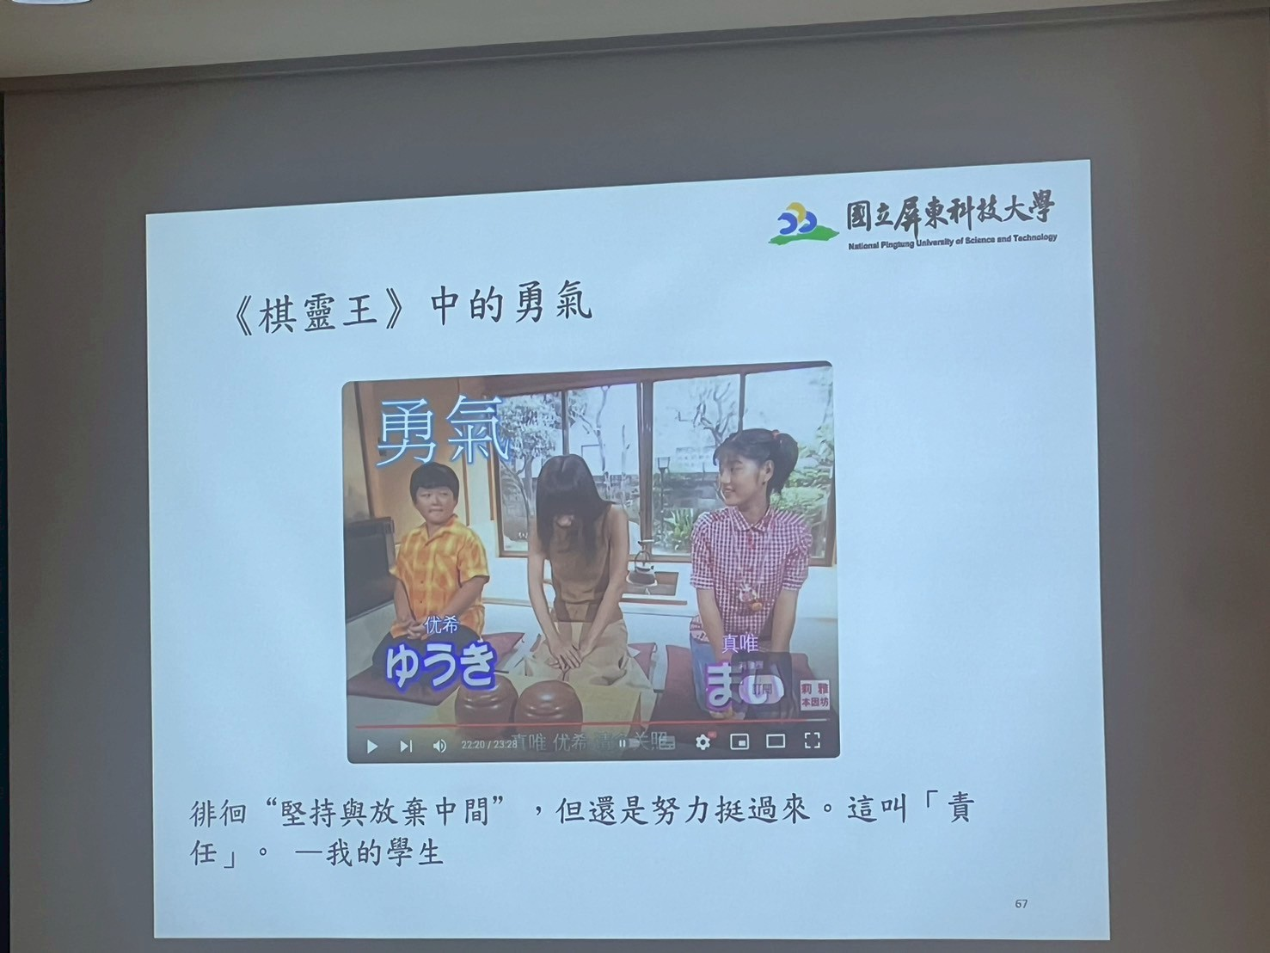ㆍNew devices

ㆍNew integration process

ㆍNew packaging

ㆍGreat opportunities

**徘徊“堅持與放棄中間”,但還是努力挺過來。這叫「責任」。**